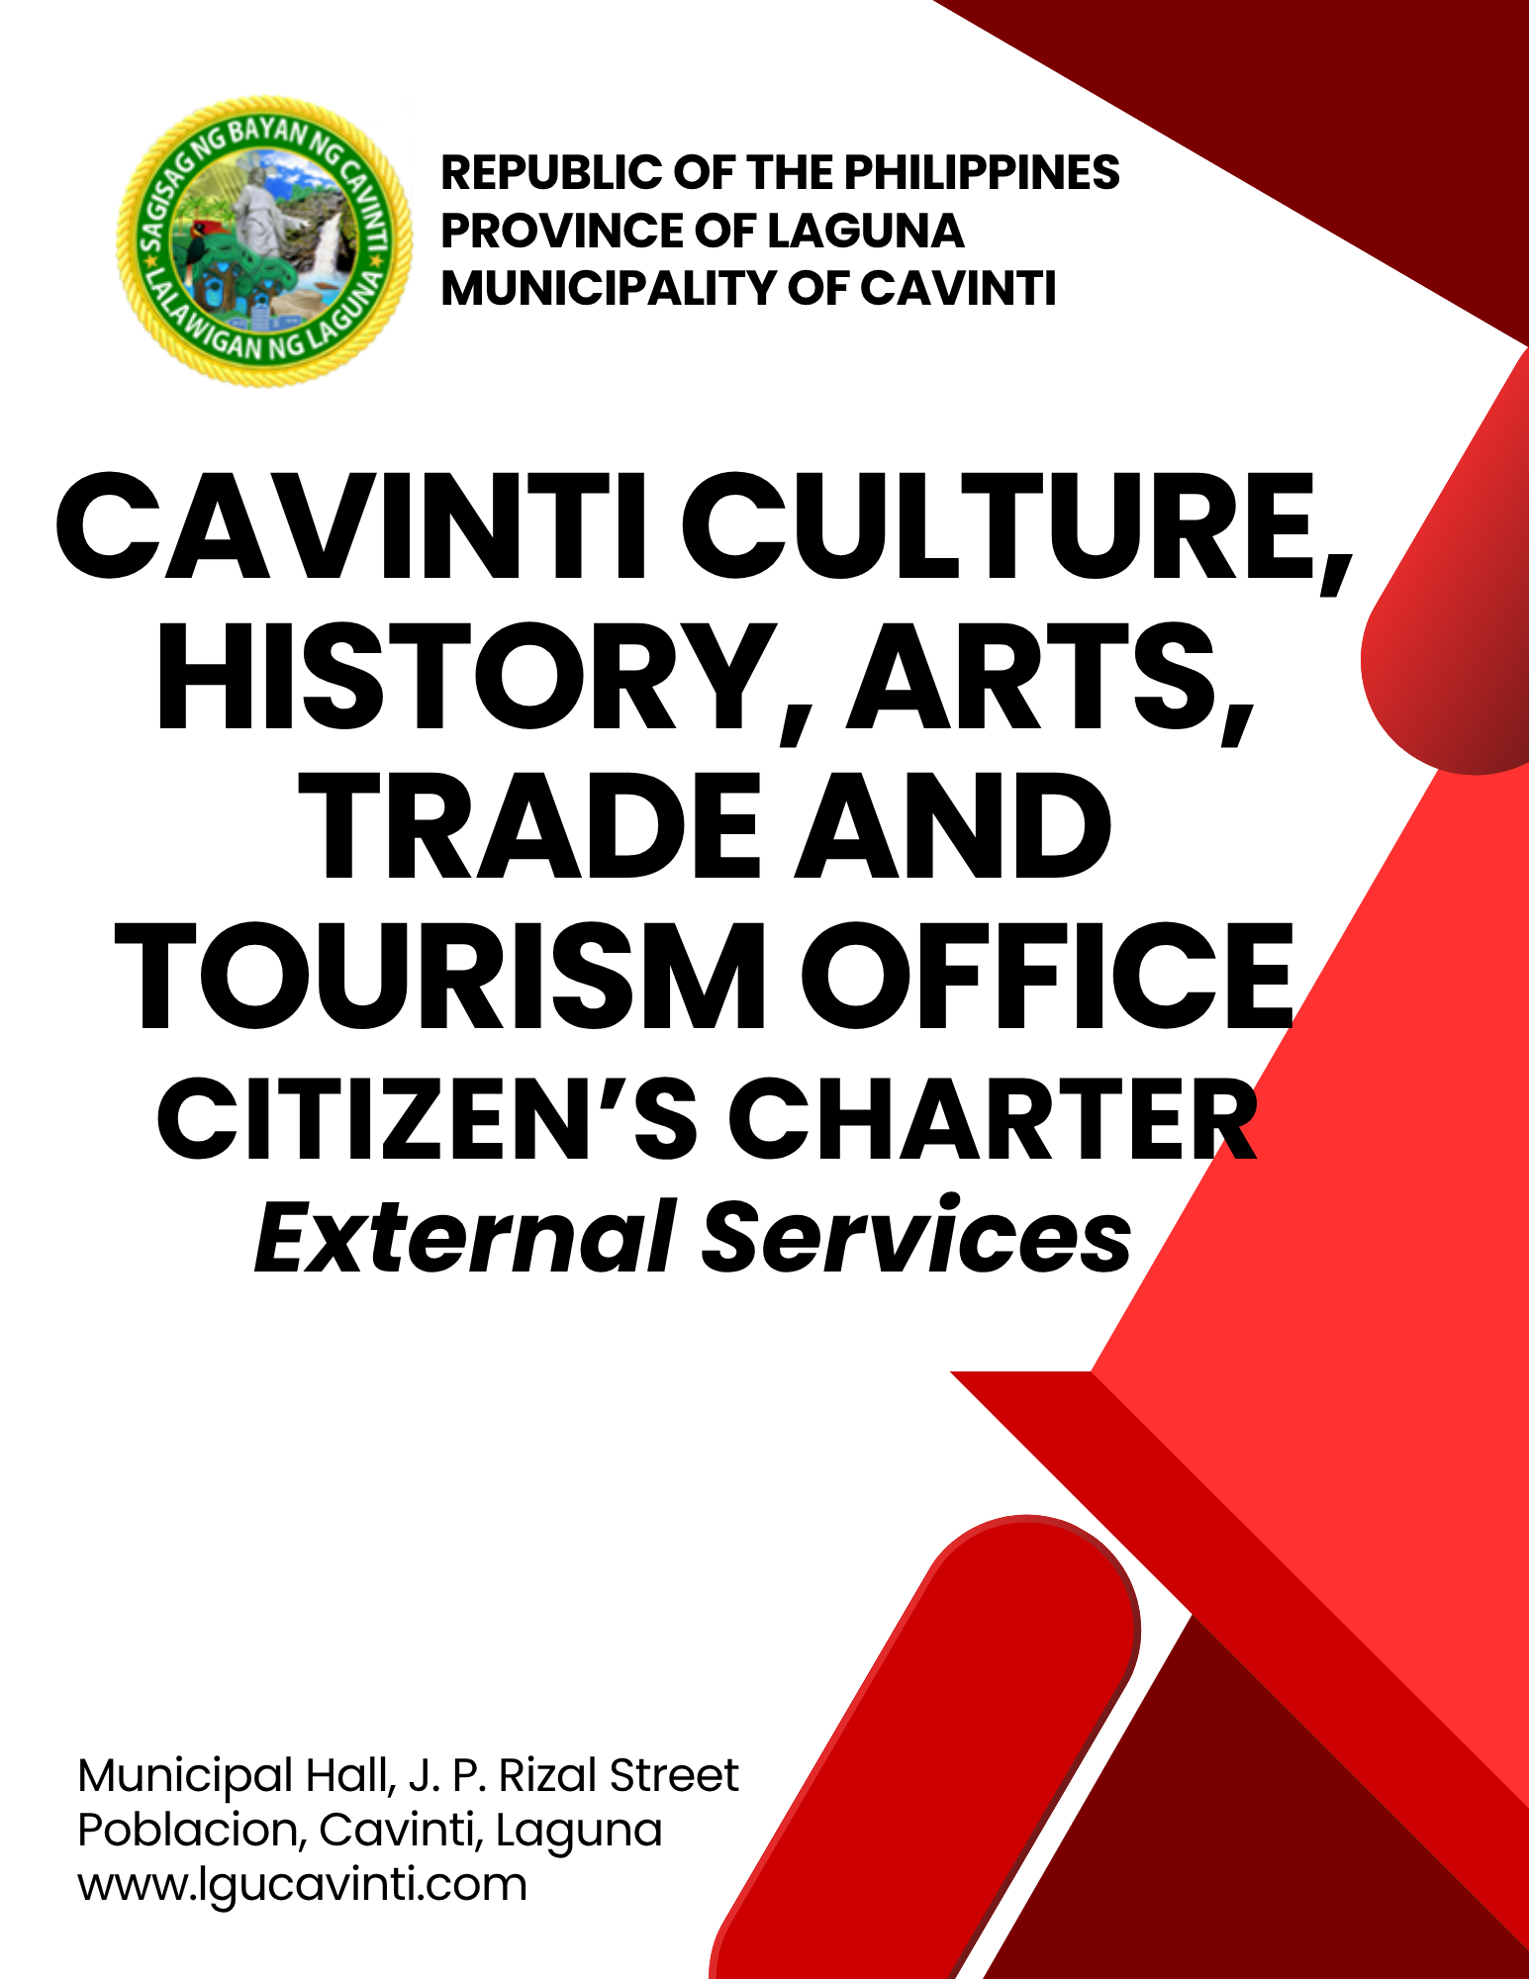

Cavinti Culture, History, Arts, Trade and Tourism Office

External Services

- Tourism Data Request

Provide official tourism-related data and information of the Municipality of Cavinti to requesting individuals, organizations, and government agencies upon receipt and verification of a formal request. This service includes validation of the purpose of the request, retrieval of available tourism data, and release of information in compliance with existing data privacy, disclosure, and records management policies.

Office or Division: | Cavinti Culture, History, Arts, Trade and Tourism Office
Classification: | Simple
Type of Transaction: | G2C - Government to Citizen  G2B - Government to Business  G2G - Government to Government
Who may avail: | Tourist/Guest/Travel Agencies
CHECKLIST OF REQUIREMENTS |  | WHERE TO SECURE
- Valid Identification (ID) (1 original copy) |  | Client
- Request Letter (1 original copy) |  | Client
CLIENT STEPS | AGENCY ACTIONS | FEES TO BE PAID | PROCESSING TIME | PERSON RESPONSIBLE
- Submit the request letter indicating the data needed and the purpose of the request. | - Receive the letter and check if the requested data is available. | None | 5 minutes | Tourism Officer  Cavinti Culture, History, Arts, Trade and Tourism Office  Tourism Operation Officer II  Cavinti Culture, History, Arts, Trade and Tourism Office  Tourism Clerk  Cavinti Culture, History, Arts, Trade and Tourism Office
- Wait for validation of the request. | - Evaluate the purpose of the request and determine the availability and releasability of the requested data in accordance with data privacy policies. | None | 10 minutes | Tourism Officer  Cavinti Culture, History, Arts, Trade and Tourism Office  Tourism Operation Officer II  Cavinti Culture, History, Arts, Trade and Tourism Office  Tourism Clerk  Cavinti Culture, History, Arts, Trade and Tourism Office
- Wait for validation of the request. | - Retrieve, compile, and prepare the approved tourism data for release. | None | 30 minutes | Tourism Officer  Cavinti Culture, History, Arts, Trade and Tourism Office  Tourism Operation Officer II  Cavinti Culture, History, Arts, Trade and Tourism Office  Tourism Clerk  Cavinti Culture, History, Arts, Trade and Tourism Office
- Claim the requested data. | - Release the requested tourism data to the client and record the transaction. | None | 10 minutes | Tourism Officer  Cavinti Culture, History, Arts, Trade and Tourism Office  Tourism Operation Officer II  Cavinti Culture, History, Arts, Trade and Tourism Office  Tourism Clerk  Cavinti Culture, History, Arts, Trade and Tourism Office
TOTAL: |  | None | 55 minutes
END OF TRANSACTION

- Tourist Assistance to Local Tourism Sites

Provide tourist assistance to individuals visiting local tourism sites in the Municipality of Cavinti through information dissemination, verification of requirements, collection of applicable fees, briefing on site rules and safety protocols, and accompaniment by designated tourism personnel to ensure visitor safety, order, and compliance with existing regulations.

Office or Division: | Cavinti Culture, History, Arts, Trade and Tourism Office
Classification: | Simple
Type of Transaction: | G2C – Government to Citizen  G2B – Government to Business  G2G – Government to Government
Who may avail: | All Individuals
CHECKLIST OF REQUIREMENTS |  | WHERE TO SECURE
- Valid Identification (1 original copy) |  | Client
CLIENT STEPS | AGENCY ACTIONS | FEES TO BE PAID | PROCESSING TIME | PERSON RESPONSIBLE
- For local or foreign tourists, proceed to the following Checkpoint Area to pay the environmental fee.  Checkpoint Areas:  - Duhat  - Caliraya  - Sitio Manandoy (CURCC, Brgy. Paowin) | - Receive the payment and issue an environmental ticket. | Php 50.00 per head | 5 minutes | Collecting Officer  Cavinti Culture, History, Arts, Trade and Tourism Office
- Proceed to the Pueblo El Salvador – Tourism Information Center before visiting the Cavinti Cave and Cavinti Falls and CCHATT Office for tourist visiting the Bumbungan Ecopark. | - Assist tourists and verify requirements. | None | 5 minutes | Tourism Officer  Cavinti Culture, History, Arts, Trade and Tourism Office  Tourism Operation Officer II  Cavinti Culture, History, Arts, Trade and Tourism Office  Tourism Clerk  Cavinti Culture, History, Arts, Trade and Tourism Office  Administrative Aide I  Cavinti Culture, History, Arts, Trade and Tourism Office
- Pay the assessed tourism fees. | - Assess applicable fees, receive payment, and issue the official receipt. | Please see Table 15 below. | 5 minutes | Administrative Aide I  Cavinti Culture, History, Arts, Trade and Tourism Office  Tourism Clerk  Cavinti Culture, History, Arts, Trade and Tourism Office
- Present the official receipt to the office. | - Conduct orientation and briefing on site rules, safety protocols, and do’s and don’ts before site visitation. | None | 10 minutes | Tourism Staff  Cavinti Culture, History, Arts, Trade and Tourism Office
- Follow instructions and comply with site rules during the visit. | - Accompany and guide tourists during the site visit to ensure safety, order, and compliance with established regulations. | None | 2 hours | Tourism Staff  Cavinti Culture, History, Arts, Trade and Tourism Office
TOTAL: |  | Please see Table 15 below. | 2 hours, 20 minutes
END OF TRANSACTION

Table 15. Schedule of Fees to Local Tourism Sites

Tourism Sites | Entrance Fee
Cavinti Underground River and Caves Complex (CURCC) | Php 650.00
Tour Guide Fee for Cavinti Underground River and Caves Complex (CURCC) (1 - 8 pax)  Additional Fee for Exceeding 1 pax | Php 600.00  Php 100.00
Pueblo El Salvador Nature’s Park and Picnic Grove going to Cavinti Falls | Php 350.00
Bumbungan Ecopark (Local/Foreign Tourist) | Php 50.00
Bumbungan Ecopark (Cavintiin) | Php 35.00

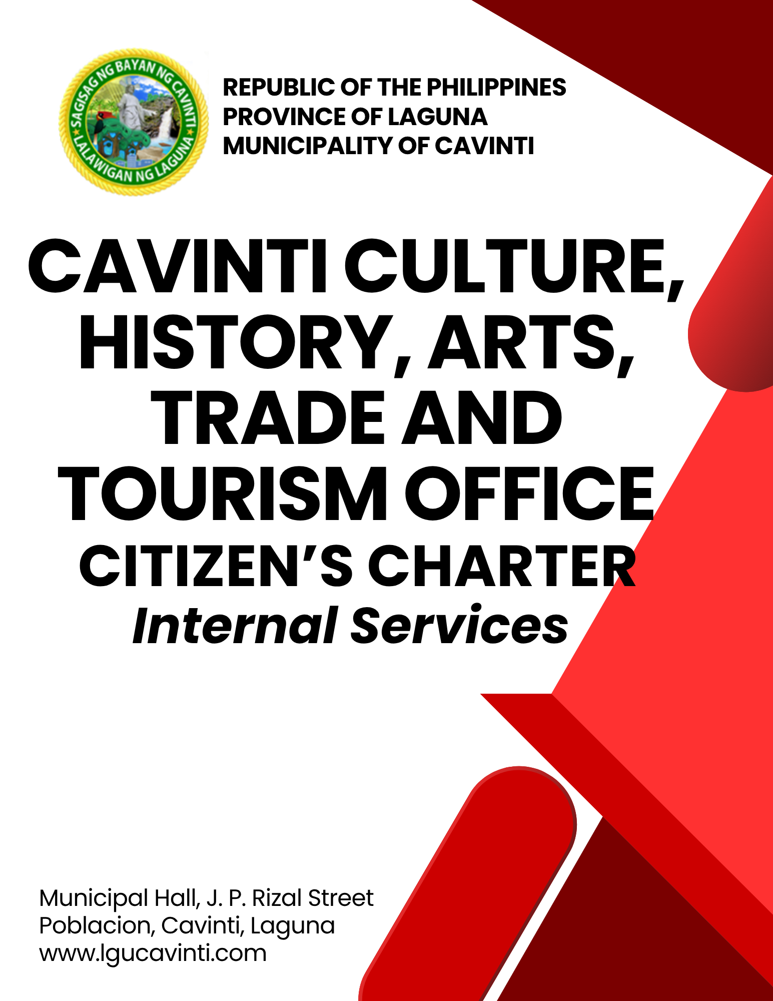

Cavinti Culture, History, Arts, Trade and Tourism Office

Internal Service

- Daily Collection Remittance

This service covers the remittance of various collections, including fees, permits, and other official charges. All collected payments must be accurately documented, supported by official receipts, and submitted to the Office of the Municipal Treasurer in accordance with relevant financial policies and procedures.

Office or Division: | Cavinti Culture, History, Arts, Trade and Tourism Office
Classification: | Simple
Type of Transaction: | G2G – Government to Government
Who may avail: | Municipal Employees
CHECKLIST OF REQUIREMENTS |  | WHERE TO SECURE
- Issued Official Receipts (1 duplicate copy) |  | Cavinti Culture, History, Arts, Trade and Tourism Office
- Collected Cash |  | Cavinti Culture, History, Arts, Trade and Tourism Office
- Abstract of Collection (4 original copies) |  | Cavinti Culture, History, Arts, Trade and Tourism Office
- Report of Collections and Deposits  (4 original copies) |  | Cavinti Culture, History, Arts, Trade and Tourism Office
CLIENT STEPS | AGENCY ACTIONS | FEES TO BE PAID | PROCESSING TIME | PERSON RESPONSIBLE
- Prepare and submit all the requirements. | - Verify, evaluate, and ensure the completeness of submitted documents. | None | 5 minutes | Cashier  Office of the Municipal Treasurer
- Prepare and submit all the requirements. | - Double-check the remitted cash for accuracy and prepare the Order of Payment. | None | 10 minutes | Cashier  Office of the Municipal Treasurer
- Prepare and submit all the requirements. | - Forward the Abstract of Collection and Report of Collections and Deposits (RCD) to the Local Treasury Operations Officer II for recording. | None | 5 minutes | Local Treasury Operations Officer II  Office of the Municipal Treasurer
- Claim the received copy of Abstract of Collection and Report of Collections and Deposits (RCD) | - Release the Abstract of Collection and Report of Collections and Deposits (RCD) to the client. | None | 5 minutes | Local Treasury Operations Officer II  Office of the Municipal Treasurer
TOTAL: |  | None | 25 minutes
END OF TRANSACTION

LIST OF OFFICES

OFFICE | ADDRESS | CONTACT INFORMATION
Office of the Mayor (OM) | 2nd Floor, Municipal Hall,  J. P. Rizal Street, Poblacion, Cavinti, Laguna | email: omcavinti@gmail.com  telephone no.: (049) 523-0012
Office of the Sangguniang Bayan (SB) | 2nd Floor, SB Hall, M. H. Del Pilar Street, Poblacion, Cavinti, Laguna | email: sbcavinti@gmail.com  telephone no.: (049) 523-4357
Office of the Municipal Administrator (OMAD) | 2nd Floor, Municipal Hall,  J. P. Rizal Street, Poblacion, Cavinti, Laguna | email: omadrecordslgucavinti@gmail.com  telephone no.: (049) 521-0147
Human Resource Management Office (HRMO) | 2nd Floor, Municipal Hall,  J. P. Rizal Street, Poblacion, Cavinti, Laguna | email: hrmocavintilaguna@gmail.com  telephone no.: (049) 523-1761
Municipal Budget Office (MBO) | 2nd Floor, Municipal Hall,  J. P. Rizal Street, Poblacion, Cavinti, Laguna | email: mbocavinti1071@gmail.com  telephone no.: (049) 523-1765
Office of the Municipal Accountant (OMACC) | 2nd Floor, Municipal Hall,  J. P. Rizal Street, Poblacion, Cavinti, Laguna | email: cavinti.omacc@gmail.com  telephone no.: (049) 503-7580
Municipal Civil Registrar Office (MCRO) | Municipal Hall, J. P. Rizal Street, Poblacion, Cavinti, Laguna | email: lcro_cavinti@gmail.com  telephone no.: (049) 523-1034
Office of the Municipal Treasurer | Municipal Hall, J. P. Rizal Street, Poblacion, Cavinti, Laguna | email: mtocavinti4013@gmail.com  telephone no.: (049) 502-4201
Municipal Planning and Development Office (MPDO) | 2nd Floor, Municipal Hall,  J. P. Rizal Street, Poblacion, Cavinti, Laguna | email: cavintimpdo@gmail.com  telephone no.: (049) 523-0366
Office of the Municipal Engineer (OME) | 2nd Floor, Municipal Hall,  J. P. Rizal Street, Poblacion, Cavinti, Laguna | email: ome.cavinti@gmail.com  telephone no.: (049) 521-8936
Municipal Disaster Risks Reduction and Management Office (MDRRMO) | National Highway, Barangay Poblacion, Cavinti, Laguna | email: mdrrmocavinti2022@gmail.com  Hotline Number: 0962-843-0781  Radio Frequency: 146.260
Office of the Municipal Social Welfare and Development (MSWDO) | Municipal Hall, J. P. Rizal Street, Poblacion, Cavinti, Laguna | email: omswdocavinti@yahoo.ocm  cavintisocialwelfare@gmail.com  telephone no.: (049) 523-0990
Municipal Environment and Natural Resources Office (MENRO) | Municipal Hall, J. P. Rizal Street, Poblacion, Cavinti, Laguna | email: menrocavinti@gmail.com  telephone no.: (049) 523-0967
Office of the Municipal Assessor (OMASS) | Municipal Hall, J. P. Rizal Street, Poblacion, Cavinti, Laguna | email: cavintiassessor@gmail.com  telephone no.: (049) 523-1023
Office of the Municipal Agriculture (OMAG) | SB Hall, M. H. Del Pilar Street, Poblacion, Cavinti, Laguna | email: maocavinti@gmail.com  telephone no.: (049) 544-2618
Cavinti Water Office (CWO) | 2nd Floor, Municipal Hall,  J. P. Rizal Street, Poblacion, Cavinti, Laguna | email: cavintiwater@gmail.com  telephone no.: (049) 523-0859
Cavinti Culture, History, Arts, Trade and Tourism Office (CCHATTO) | Ecopark, Barangay Tibatib, Cavinti, Laguna | email: tourismcavintilaguna@gmail.com  telephone no.: (049) 540-3924
Office of the Municipal Health Officer (OMHO) | Barangay Anglas, Cavinti, Laguna | email: cavintirhu@yahoo.com  telephone no.: (049) 523-0148
General Service Office (GSO) | Municipal Hall, J. P. Rizal Street, Poblacion, Cavinti, Laguna | email: gso.lgucavinti@gmail.com  telephone no.: (049) 523-1042
Public Employment Service Office (PESO) | Municipal Hall, J. P. Rizal Street, Poblacion, Cavinti, Laguna | email: @gmail.com
Municipality of Cavinti | Municipal Hall, J. P. Rizal Street, Poblacion, Cavinti, Laguna | cavintimunicipalgovernment@gmail.com

FEEDBACK AND COMPLAINTS MECHANISMS
How to send feedback? | Answer the client feedback form and drop it at the designated drop boxes across the vicinity of the Municipal Building or you may contact us through the following to send in any suggestions, compliments and/or complaints.  cavintimunicipalgovernment@gmail.com Telephone No. 523-0129 local 100
How feedback is processed? | Every last working day of the week, the assigned personnel will open the drop box and compiles and records all the feedback submitted.  Feedbacks requiring answers will be forwarded to the relevant offices and they will be required to provide an answer within three (3) days upon receipt of the feedback.  The response will then be forwarded/relayed to the citizen if applicable.
How to file a complaint? | Answer the client complaint form and drop it at the designated drop boxes across the vicinity of the Municipal Building.  Make sure to provide the following information:  - Name of person being complained  - Incident  - Evidence
How complaints are processed? | The responsible/assigned personnel will open the complaint drop box on a daily basis and evaluate each complaint.  After thorough review of the complaint, an investigation will commence and require the personnel concerned for their explanation.  A report containing all the details of the incident and the findings shall be submitted to the head of agency for appropriate action.  Afterwards, feedback will be given to the client (complainant).
Contact Information of ARTA | email address: info@arta.gov.ph  contact nos.  PLDT - 1-ARTA (12782)  Smart  0920-925-3078  0998-856-8338

